Chat Messenger
Requirements Document
Table of Contents
1 Introduction 3
1.1 Purpose and Scope 3
1.2 Target Audience 3
1.3 Terms and Definitions 3
2 Product Overview 4
2.1 Users and Stakeholders 4
2.1.1 Stakeholders 4
2.2 Use cases 5
2.2.1 Use Cases 5
3 Functional Requirements 6
3.1 Functional Requirements 6
3.1.1 Functional Requirements (specified) 6
4 Nonfunctional Requirements 7
4.1 Nonfunctional Requirements 7
4.1.1 Security 7
4.1.2 Scalability 7
4.1.3 Maintenance 7
4.1.4 Out-of-scopes 7
5 Milestones and Deliverables 8,9
5.1 Milestone/Deliverables (Gantt Chart) 8
5.1 Requirements Doc….………………………………………………………..8
5.1.1 Design Doc 8
5.1.2 Implementation/Code………………………………………………………..8
5.1.3 Test Plan 9
5.1.3 Test Plan……………………………………………………………………...9
5.1.4 Demonstration & Project Report 9

Introduction
This is the requirements document pertaining to the CS300 Chat Messenger application. Chat Messenger consists of both Server (SVR) and Client (CLI) applications. The Server application is to handle the security and access of connections, as well as the storage of user information and comprehensive chat logs. The Client is to facilitate user login/logoff, local chat logs, user registration and UI.

Purpose and Scope
This project will be for creating a chatroom with direct messaging capabilities, which allows multiple users to interact via text-based messaging.

Target Audience
This requirements document will provide essential information to software developers interested in implementing the system or something similar.

Terms and Definitions
SVR: The server application component of Chat Messenger.
CLI: The client application component of Chat Messenger.
User: A person utilizing Chat Messenger for communication purposes.
Customer: The entity requesting the design and implementation of Chat Messenger (stakeholder).
Dev: Developer(s) of Chat Messenger.

Product Overview
Users will connect to the Chat Messenger SVR via the Chat Messenger CLI. They will interact with other users via text messages readable via the chatroom style message screen.

Give a high level description of the functionality of the project here. Describe the purpose of this section. It may be useful to give your definition of a user, a stake holder and a use case. If there are scope limitations to the project, i.e. things you will not be doing, or are not required to do, this is a good section to put those.

Users and Stakeholders
Users are the individuals utilizing Chat Messenger for the purpose of communicating over a text-based medium with one or more people.

Stakeholders are the company which charged us with the task of developing and implementing Chat Messenger.

Stakeholder
The stakeholder will be responsible for providing additional requirements (at cost) not covered by this requirements document, as well as ensuring that Chat Messenger delivers the requested features as described to the dev. After completion of the Chat Messenger project, control of the software passes onto the stakeholder, while ongoing support of Chat Messenger will be available from dev (at cost).

Use cases

Use Case 1
User registers and logs into Chat Messenger via CLI. User is presented with list of other users and their status (online/offline). User sends and reads messages, which are stored on the SVR. User reads status updates from other users. User logs off of Chat Messenger.
User
Client
Server
Create account
register(new_user)
Provide login credentials
User sees userlist and user status
File System
addUser(new_user)
authenticate(user_info)
Send message to room
userMessage(mssg)
storeMessage(mssg)
User reads message on screen
showMessage(mssg)
provideUsers(user)
displayUser(user)
displayUser(user)
Send direct message to user
directMessage(direct_mssg)
storeDirectMessage(direct_mssg)
login(user_info)
User reads direct message
showDM(direct_mssg)
User logs out of application
logout(user_info)
updateStatus(user_info)
User reads login/logout activity
presentStatusUpdate()

Functional Requirements
Functional requirements for this project are those that define the operations the application will be facilitating as defined by the stakeholder.

Functional Requirements
Allow an indefinite amount of users to securely connect and interact via a text medium, either via general room-wide texting or direct messaging to specified users. The application must provide error messages when appropriate, as well as inform the greater userbase of the status of other users. Users are required to use a password to log into the application, and their messages are to be stored and accessible.

Functional Requirement (specified)
- User must register an account name and password in order to login.
- User must provide account name and password to login with CLI.
- User must be presented with a user interface.
- Said UI must display both global and direct messages, as well as a user list stating the users status. Also a logout button.
- User must double-click a users name in the user list to send a direct message.
- The SVR must store information on user accounts, as well as their connected status. SVR must also store chat log information, and provide it to users when requested.
- CLI or SVR must provide error messages for inappropriate account credentials, or when messaging a user that is offline.

Nonfunctional Requirements
Non-functional requirements for this project are those that define behaviors of the application, determined by the dev.

Nonfunctional Requirements
- Security
- Scalability
- Maintenance
- Out-of-scopes

Security
User authentication will be required prior to successful connection. This will be achieved with a password system. The user will determine a password upon account creation.

Scalability
Chat Messenger is designed to be a means of communication for an indefinite amount of people. However due to the nature of the UI implementation, it is likely not suited for massive communication, realistically between 2-30 people.

Maintenance
No maintenance required. This is a chat room without specified rules, and is by nature subject to anything from spam to account-fraud. All messages are kept in the SVR chat log. All that need be done for upkeep is making sure the SVR application is running, and that the required external data files are properly accessible.

Out-of-scopes
1-on-1 communication windows, user blocking, account banning, text customization, password changing, username changing, account deletion, censoring, message deletion, message editing – are all features not presently being considered for implementation.

Milestones and Deliverables
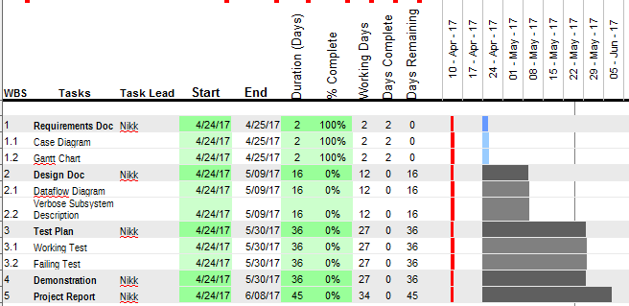

Requirements Document
This document.

Design Document
Specifications for the implementation of Chat Messenger. Verbose descriptions of subsystems, classes, and features, as well as a UML diagram and Data Flow Diagram.

Implementation/Code
The Magnum Opus of Chat Messenger. To be created according to this document, with the aid of the Design Document. To be used for the purpose of designing CLI and SVR applications, external data files, and to be used for testing use cases.

Test Plan
Write-up on processes used to test each of the classes and features of Chat Messenger. Also to be used for the purpose of testing completeness of the system via use case scenarios.

Demonstration & Project Report
Demonstration of the project to be performed prior to the specified time period, the week before final exam (specifically; June 5th to the 7th as a window), with the stakeholders in attendance. Following this, a post-mortum of the project will be provided for the purpose of capturing 'lessons learned' and areas where the application/project could (have) used improvement.

